Azure Storage Account - Assignment 6

Thanks to Drop staff and teachers. -- Here is my homework from the training series...

Deploy an Azure Virtual Machine

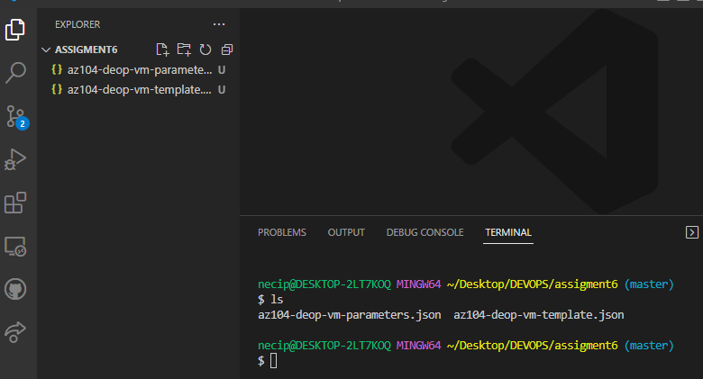

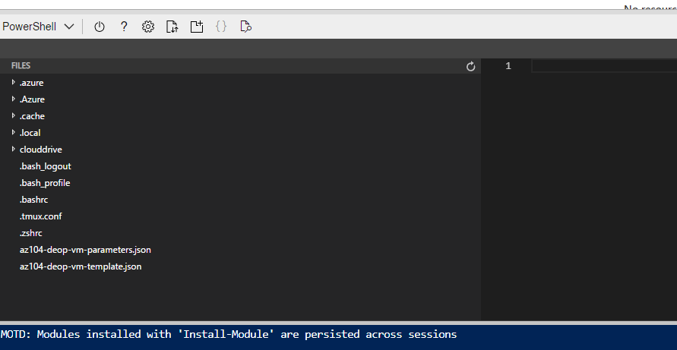

Create and Configure Azure Storage Account

Manage Blob Storage

Manage Authentication and Authorizaztion For Azure Storage

Create and Configure Azure File Share

I got this error. Then I fixed some error…

Finaly worked

Manage Network Access for Azure Storage

New-Item -Type Directory -Path 'Z:\\az104-deop-folder'

New-Item -Type File -Path 'Z:\az104-deop-foler\az104-deop-file.txt'